# Appendix -3: Facility Numbers

|  |  |  |  |
| --- | --- | --- | --- |
| **#** | **Program Title** | **Submitting Hospital** | **Facility Number** |
| 2 | a) Sarcoma (Chemotherapy)  b) Sarcoma (Pathology)  c) Sarcoma (Prosthesis) | Royal Victoria Regional Health Center | 606 |
| Kingston General Hospital | 693 |
| Grand River Health Corporation | 930 |
| Windsor Regional Center | 933 |
| Thunder Bay Regional Health Sciences Centre | 935 |
| London Health Sciences | 936 |
| Hamilton Health Sciences Corporation | 942 |
| University Health Network | 947 |
| Sunnybrook Health Sciences Centre | 953 |
| The Ottawa Hospital | 958 |
| Health Sciences North | 959 |
| Sinai Health System | 976 |

# Appendix – 11: Valid 2-digits Postal Codes

(Source: Cancer Care Ontario's Data Book - 2012-2013, Appendix B - Province and State codes, at link https://www.cancercare.on.ca/ext/databook/db1213/databook.htm).

The table below provides list of valid 2 digit postal codes for province and State codes.

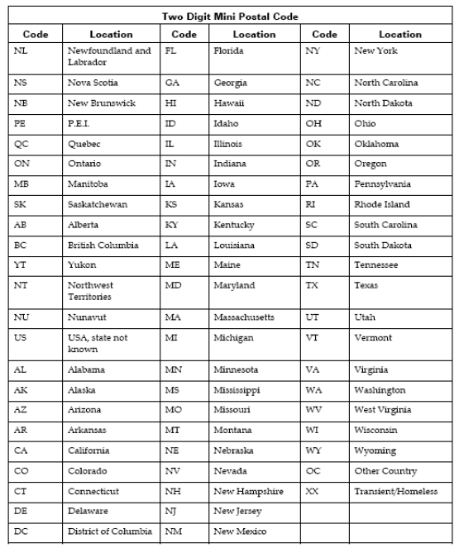

# Appendix -20: Morphology Codes

This is a complete listing of valid Morphology codes and includes the new Haematopoietic codes effective January 2010.

Citation for new classification:

WHO Classification of Tumours of Haematopoietic and Lymphoid Tissues, 4th ed., edited by S. H. Swerdlow, et al., International Agency for Research on Cancer, Lyon, 2008. ISBN 978-92-832-2431-0

(For details, please refer Cancer Care Ontario's Data Book - 2012-2013, Appendix 1.36 - Morphology Codes, at link https://www.cancercare.on.ca/ext/databook/db1213/databook.htm)

# Appendix -21: ICDO-3 Topography with Laterality

This is a table of topography codes where laterality is applied as stipulated in the FORDS manual.

(For details, please refer Cancer Care Ontario's Data Book - 2012-2013, Appendix 1.3 ICDO-3 TOPOGRAPHY with Laterality, at link https://www.cancercare.on.ca/ext/databook/db1213/databook.htm)